STANDARD OPERATING PROCEDURE
TB Import In caseware with assign mapping

What is a Trial Balance?
- A trial Balance is a financial report showing the closing balance of all accounts in the General Ledger at a point in time. Creating a Trial balance is the first step in closing the books at the end of an accounting period.

- The purpose of the trial balance is to ensure that the accounting equation
(Assets = Liabilities + Equity) is in balance and to provide a basis for preparing financial statements.

- The trial balance relies on the principles of double-entry accounting, where every transaction has equal and opposite effects on at least two accounts. As a result, the total debits must equal the total credits in the trial balance.

Why do we Assign Map numbers to Trial Balance Items?
- For the Preparation of Audit Reports and Financial Statements in caseware software, we need to Import Trial Balance first, so we can prepare financials from the Ending balances of each account of Trail Balance.

- To import the Trial Balance, we will assign Map Numbers and Map Descriptions to each line item in the formatted TB. We will refer to last year's Mapping, Chart of accounts to provide mapping for every line item.

- Assigning trial balance items with designated map numbers and decryption ensures compatibility with Caseware, optimizing the software's functionalities for comprehensive financial analysis, reporting, and audit trail establishment.

- Map Number – The number assigned by the auditor to categorize the same kind of accounts in a group.

- Map Description – A Description provided by the auditor to categorize the same kind of accounts in a group.

How to Assign Mapping to Trial Balance Items?
We have below-mentioned situations for assigning mapping to the trial balance items:
- In Case of Existing Client:
If we have an existing client, we will utilize the previous year's TB import file by using the V-Lookup formula to obtain map numbers and descriptions.
However, if we find a new account in the current year TB or doesn’t have past balances, we carefully assign a new map number and description as per the nature of the account or we match them with similar items that already have assigned map numbers.

- In Case of a New Client or First Time Audit Client

If we have a New Client or first-time Audit Client then we systematically assign mapping to every line item of trial balance based on the nature of such account.
We can use the chart of accounts to identify the category of such accounts as assets, liabilities, equity, revenue, and expenditure.

For the implementation of standard procedures commonly employed by various CPA firms, the assignment of map numbers follows a systematic approach. Specifically:

- For items categorized as Assets, map numbers are assigned in a series of 10,000, based on the line items.

- For items with a Liability nature, map numbers are provided in a series of 20,000, contingent on the line items.

- Similarly, for line items characterized by the nature of Equity or Fund balance, map numbers are assigned in a series of 30,000, dependent on the line items.

- In the case of Revenue-related line items, map numbers are assigned in a series of 40,000, considering the line items.

- For line items reflecting Expenditure, map numbers are assigned in a series of 50,000 to 60,000, depending on the line items.

Import Trial Balance in Caseware

Why do we import Trial Balance in Caseware?

- Importing the trial balance ensures that the financial data entered into Caseware is accurate. This helps in producing reliable financial statements and audit reports.

- If we opt to enter all the financial data manually into Caseware, then it can be time-consuming and there could be a possibility of chances to errors. Importing the trial balance saves time and reduces the risk of errors associated with manual data entry.

- Importing the trial balance creates an audit trail within Caseware. Once the trial balance is imported into Caseware, auditors can perform various analyses and generate reports, and lead sheets using the caseware's tools and functionalities.

- Auditors can track changes made to the financial data and ensuring transparency and accountability throughout the auditing process.

- It enables a comprehensive review of the financial data and ensures compliance with accounting standards and regulations.

How to Import Trial Balance in Caseware?

To Import the Trial Balance in Caseware,
First, we have to prepare a Trial balance Import sheet. In this sheet, we have to provide Map numbers to TB line items. (Refer to the above “How to Assign Mapping to Trial Balance Items?”)
After preparing the TB import sheet, our next step is to import the sheet in caseware. The Trial balance import file should be in Excel format. Here are the steps to import trial balance in caseware:-
- Open caseware, Click the tab labeled "Engagement" in the top menu.

- Open the engagement menu, and locate the "Import" button. This button has a downward arrow indicating a dropdown menu. Then Click on the “Import” button.

- From the dropdown list, select "Excel File..." to open a dialogue window where you can browse and select the Excel file you wish to import.

- After clicking on the Excel file mentioned above, the dialogue box below will appear on which we select the “Browse” button to select the path where the TB import sheet is located. Then click the “Next” button to move forward.
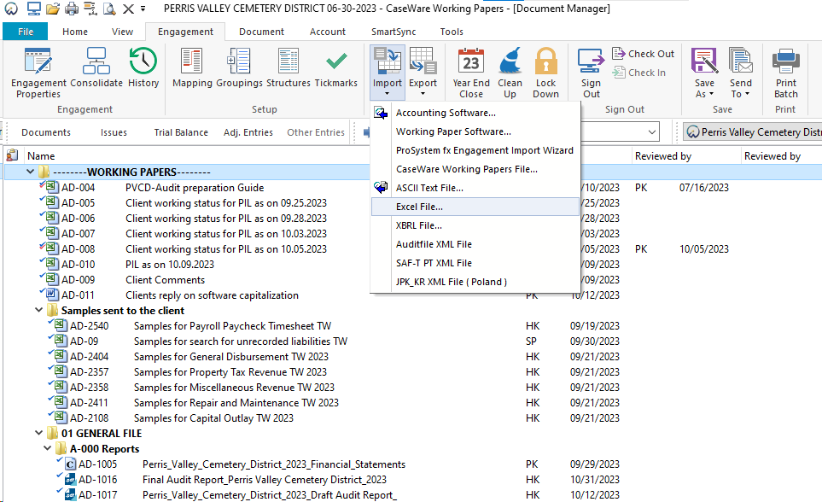

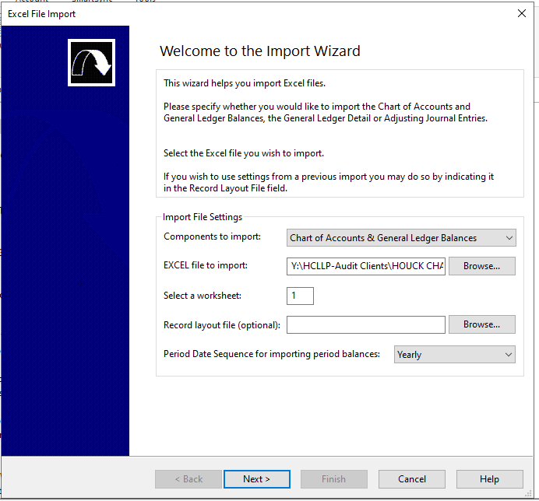

- After you press the "Next" button, a dialog box will appear. In this box, you can choose rows that you don't want to import into your Trial Balance (TB).

To exclude a specific row, simply click on the checkbox beside that row. When you click on it, that row will be marked and will not be included in the import.

In the next step, we will skip the first row because it contains headings like accounting string, account description, balance, etc.

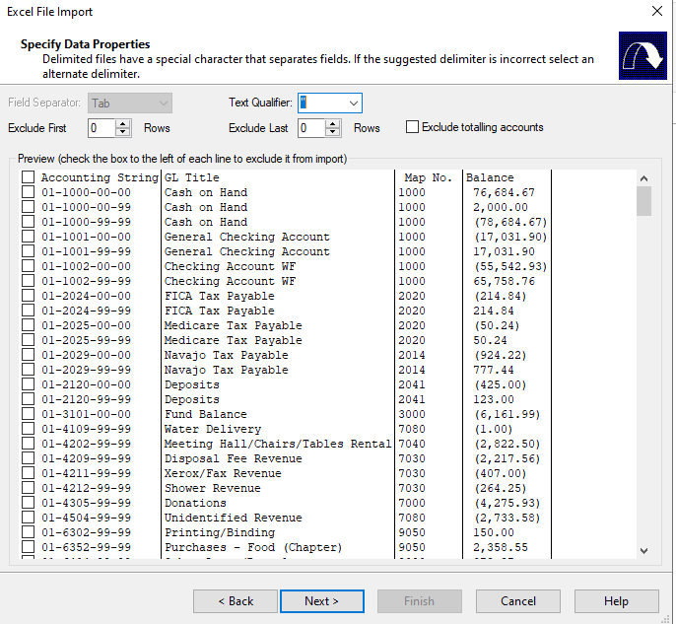
- After excluding unnecessary information
Our next step will be to select Account Description, Account Number, Map Number, and Balance which will be selected as described below:-

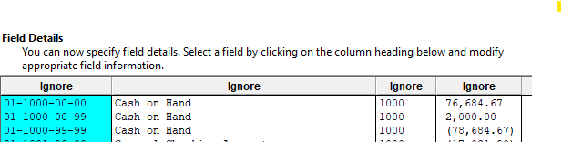
- For the selection of Account Number, we will select the “Ignore” Tab of the column in which accounting strings are mentioned.

- After clicking on the “Ignore” tab of the accounting string, a below-described dialogue box will open, now we will select “Account details” then select ”Account Number” respectively.

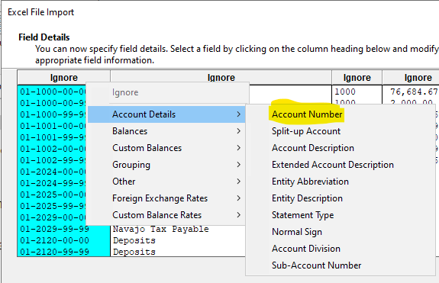

- After selecting Account Number, we will select “Account Description” by using the above method or pattern.
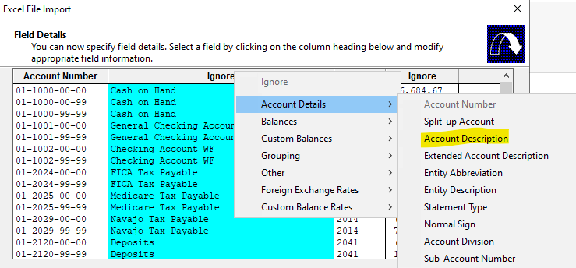

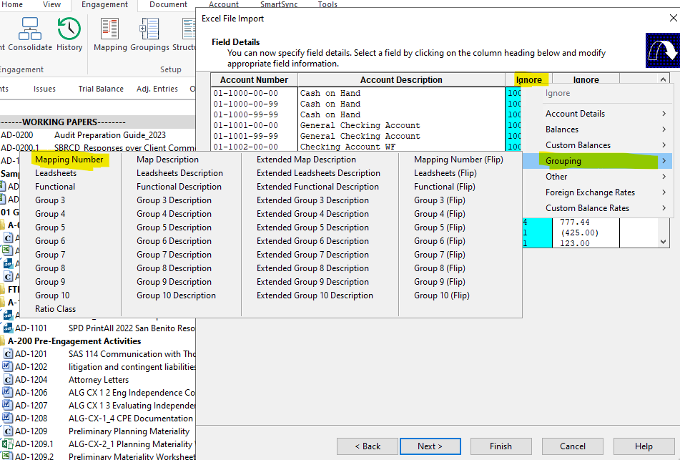
- After selecting the Account Description, the next step is identifying the Map number. For this, first, we have to select the “Ignore” Tab in which map numbers are specified, Select “Grouping” and then select “Mapping Number”.

- After selecting Map Number, the next step is to identify the column of “Balance”.
For this, we select the “Ignore” tab having column of Balances, then click on “Current Year Balance”. After that click on “Opening Balance”.

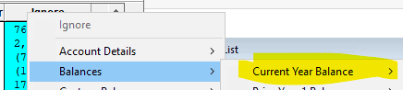

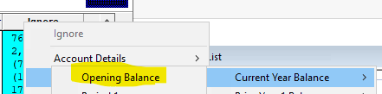

- If any TB import sheet has Prior year balances then we have to select them also.
For this, we select the “Ignore” tab having column of Balances, then click on “Prior Year 1 Balance”. After that click on “Opening Balance”. (For new clients)
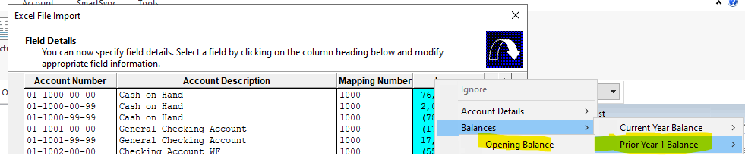

- After selecting all the Columns, the next step is to click on the “Next” button.
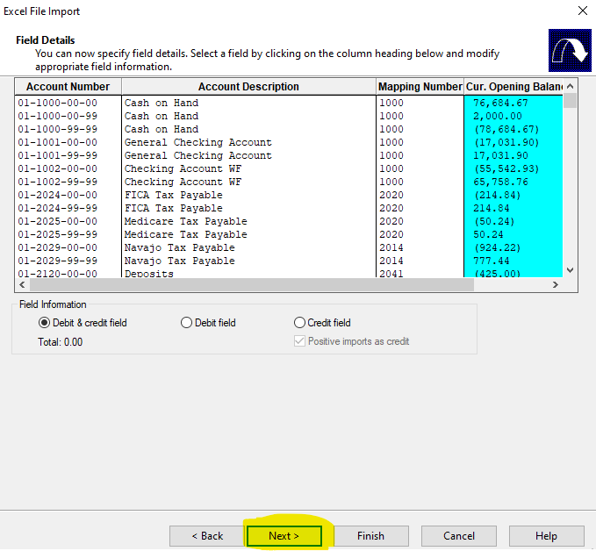
- After this below described dialogue box will appear,

- This dialogue box is required when our Account number (Accounting string) having “Fund-code” wise string and for which we have to identify the Funds as “entity”.

- To identify the same we have to click on the dialogue box
“Account Number and Entity share same field but are not separated”.

- By clicking that dialogue box two more dialogue boxes will appear, Now we need to denote the Fund code’s start position in the “Entity Start Position” box and the number of characters in the fund code is in the “Number of Characters” box

- For example, if an entity has an Accounting string such as “01-1000-00-00” where the fund code is “01” then the Entity Start Position will be 1, and the Number of Characters will be 2.
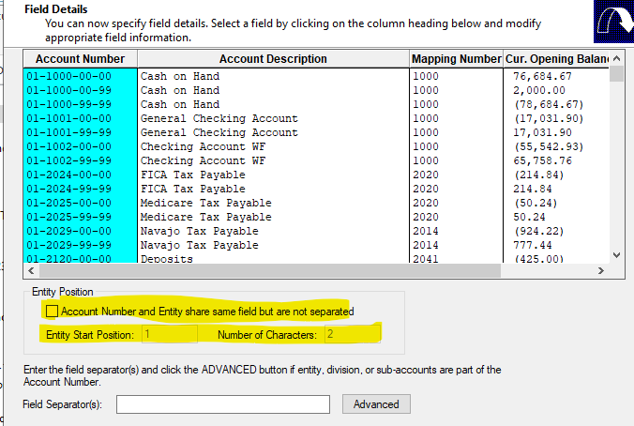

- After the above procedure is completed, the below dialogue box will appear in which we have to assign “entity/mapping” to those items that remain unassigned, and then we have to click on the “Next” button.
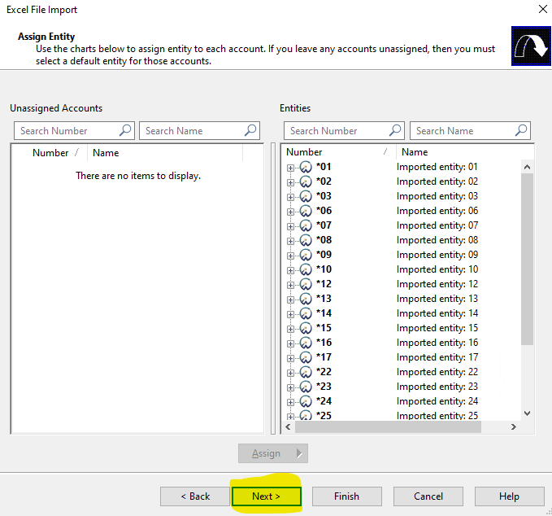

- After completion of the above procedure, the below dialogue box will appear in which we have to assign “entity/mapping” to those items that remain unassigned. Then we have to click on the “Next” button.

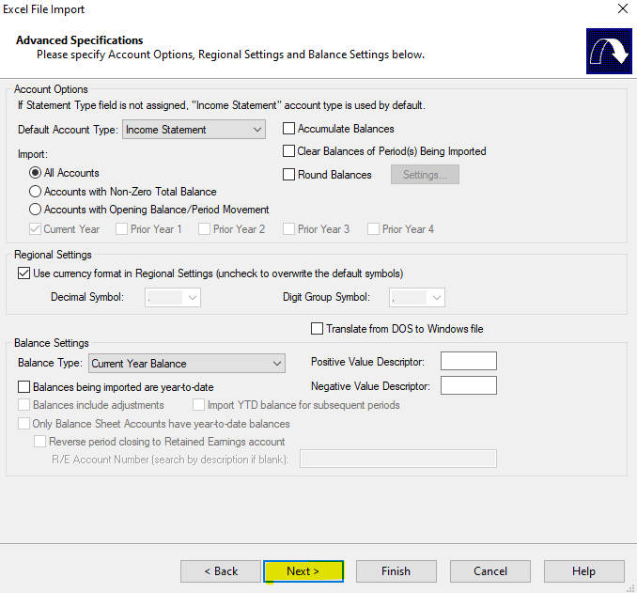

- After completion of the above procedure, the below dialogue box will appear which shows “newly added/modified” accounts. Then we have to click on the “Next” button.

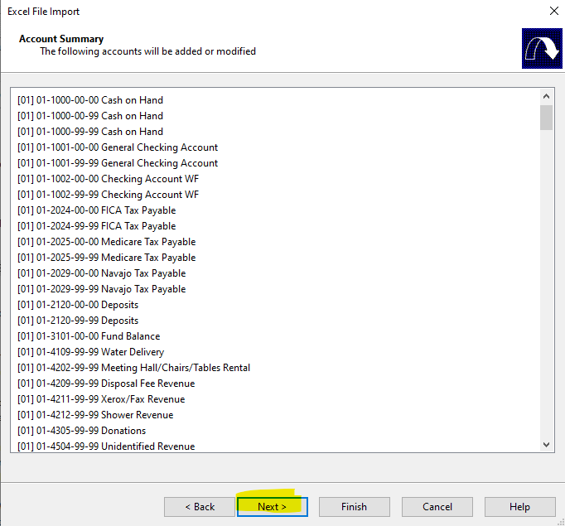

- After completion of the above procedure, the below dialogue box will appear on which the “Import” button will appear, by clicking on it the trial balance items will be successfully imported into the caseware.

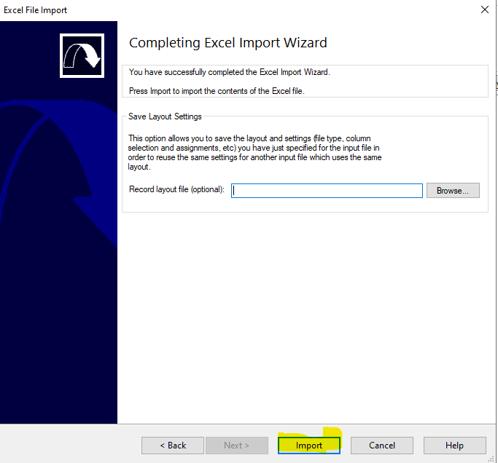

- After completing of the Trial Balance Importing, it is necessary to verify the accurate import of each account code along with its respective mapping.

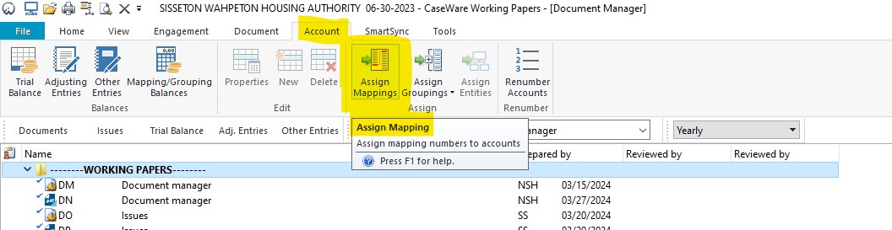
- For this, we will open caseware and navigate to the “Account” tab in the top menu. A dialogue box will appear where we need to click on the “Assign Mappings” button.

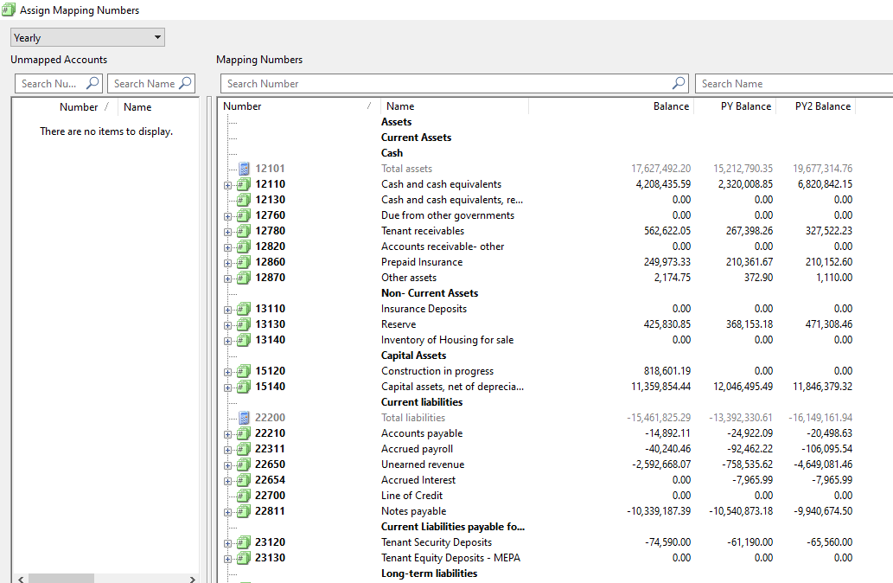
- Upon clicking the “Assign Mappings” button, the Trial Balance with mapping details will be displayed as shown below.

